Name : Rohit Kadam Roll no: 218

Experiment no7: Display servertime using digital clock.

Code:

<!DOCTYPE html>

<html>

<head>

<title>Digital Clock</title>

<style> body { font-family: Arial, sans-serif; background: #000; color: #0f0; text-align: center; font-size: 48px; margin-top: 20%;

}

</style>

</head>

<body>

<?php

// Get the current server time date_default_timezone_set('UTC'); // Change to your timezone if needed

$serverTime = date("H:i:s");

?>

<div id="clock"><?php echo $serverTime; ?></div>

<script> function updateClock() { const clock = document.getElementById('clock'); let time = new Date();

clock.innerHTML = time.toLocaleTimeString();

}

setInterval(updateClock, 1000);

</script>

</body>

</html>

Output:

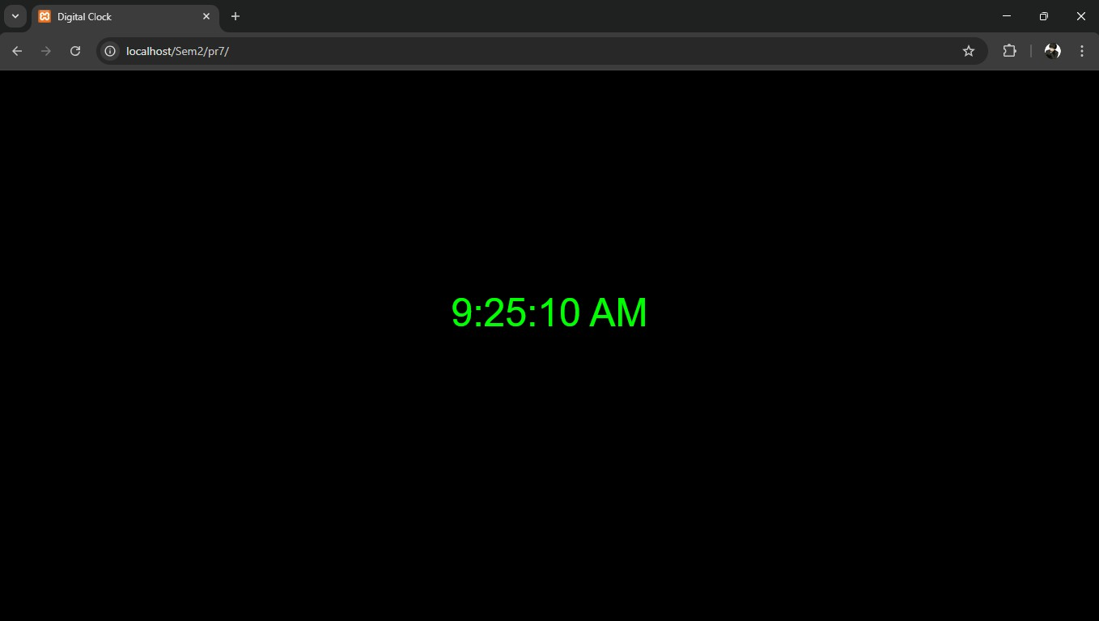

Name :Sarvesh Padole Roll no: 233

Experiment no8: Write a PHP program to implement sign-In and Sign-out functionality.

Login.php

<?php

session_start();

// Dummy credentials

$valid_username = 'admin';

$valid_password = '12345';

// Handle form submission if ($_SERVER['REQUEST_METHOD'] === 'POST') { $username = $_POST['username'] ?? '';

$password = $_POST['password'] ?? '';

if ($username === $valid_username && $password === $valid_password) {

$_SESSION['user'] = $username; header('Location: welcome.php'); exit;

} else {

$error = "Invalid username or password!";

}

}

?>

<!DOCTYPE html>

<html>

<head>

<title>Sign-In</title>

</head>

<body>

<h2>Login</h2>

<?php if (!empty($error)) echo "<p style='color:red;'>$error</p>"; ?>

<form method="post" action="login.php">

Username: <input type="text" name="username" required><br><br>

Password: <input type="password" name="password" required><br><br>

<button type="submit">Sign In</button>

</form>

</body>

</html>

Welcome.php

<?php session_start(); if (!isset($_SESSION['user'])) { header('Location: login.php'); exit;

}

?>

<!DOCTYPE html>

<html>

<head>

<title>Welcome</title>

</head>

<body>

<h2>Welcome, <?php echo htmlspecialchars($_SESSION['user']); ?>!</h2>

<p><a href="logout.php">Sign Out</a></p>

</body>

</html>

Logout.php

<?php session_start(); session_unset(); session_destroy(); header('Location: login.php'); exit;

Output:

